**Renaming the HC-05 Bluetooth Module Using AT Command**

Last Update: 20 March 2018  
Author: Louis Yong

**OVERVIEW**

This white paper describes the procedure to change the device name of the HC-05 Bluetooth module (HC-05) using the AT command set. The default settings in the HC-05 is standardised as follows:

Bluetooth name: **HC-05**Security code: **1234** or **0000**

However, the conditions in a classroom environment with multiple HC-05 result in students having difficulty in identifying which HC-05 to pair to their mobile phones or computers.

The solution is to change Bluetooth name of the HC-05 to a unique name using the AT command set.

**PART 1: UNDERSTANDING THE ISSUE**

Conducting a class with multiple Arduino and HC-05 results in confusion because students cannot determine which Bluetooth name to select to pair. All HC-05 use the same default settings:

Bluetooth name: **HC-05**Security code: **1234** or **0000**

One workaround is to have everyone power off their HC-05, and then one student at a time power on her HC-05 and pair it to her mobile phone or PC. Once paired, she powers off her HC-05 and then it’s the next student’s turn. This is time consuming and a distraction to the learning process.

Fortunately, we can change the default settings of the HC-05 using the AT command set.

**PART 2: CONNECTING THE CIRCUIT**

1. You will need the following components:  
   •  Arduino UNO (with Arduino IDE installed on a PC)  
   •  HC-05  
   •  Breadboard  
   •  Jumper wires
2. Assemble the following circuit.

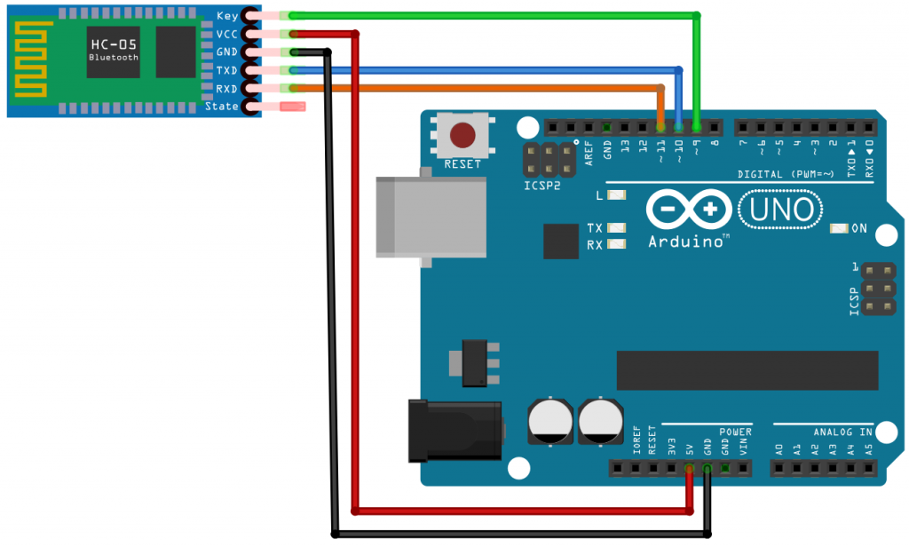

Follow the labels on the HC-05. If the KEY pin is not available, see *If Key Pin Is Not Present*below*.*

**WARNING:**  
The HC-05 is a 3.3V system. This circuit doesn’t use voltage dividers to drop 5V to 3.3V for this short procedure. It is not advisable to leave the HC-05 connected to the 5V Arduino pins for a long time.

**If Key Pin Is Not Present**

Some HC-05 do not have the KEY pin on the breakout board. Instead they have an EN or WAKE pin. In this case, connect a jumper cable to the KEY pin (inside the plastic sleeve) on the IC.

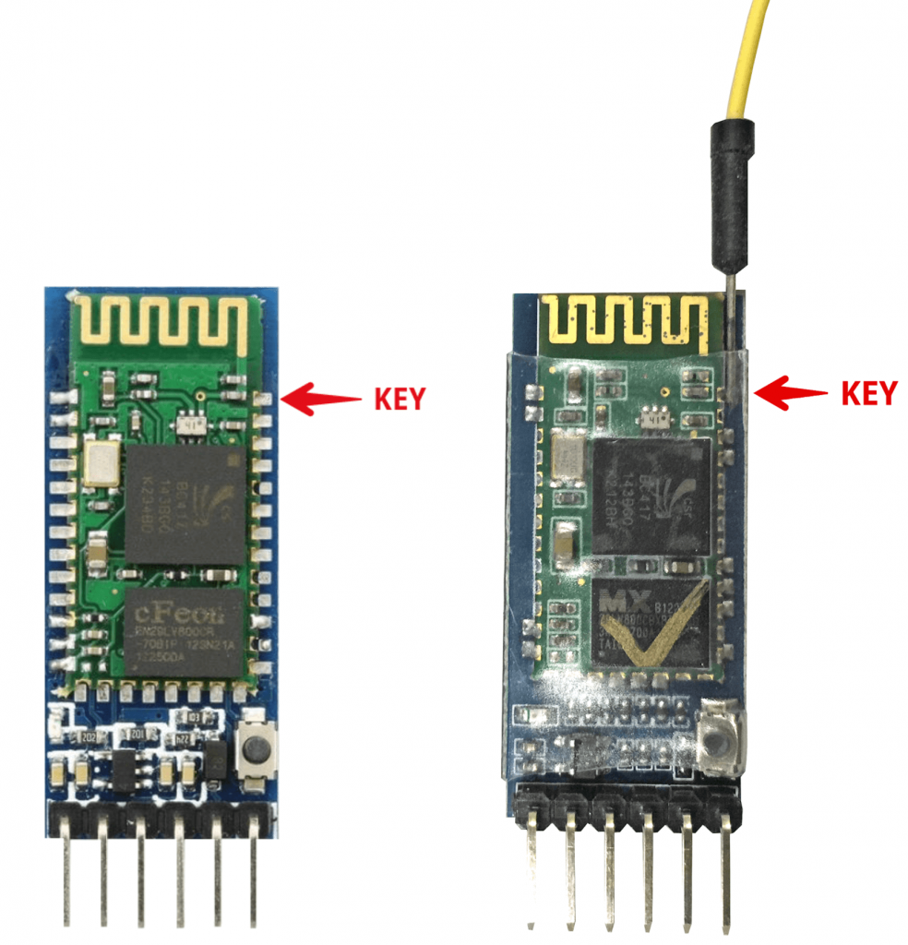

**PART 3: PROGRAMMING THE ARDUINO**

Upload the following program into the Arduino.

For more information on how to upload a program to the Arduino, visit <https://www.arduino.cc/en/Guide/ArduinoUno>

/*

AUTHOR: Hazim Bitar (techbitar)

DATE: Aug 29, 2013

LICENSE: Public domain (use at your own risk)

CONTACT: techbitar at gmail dot com (techbitar.com)

*/

#include <SoftwareSerial.h>

SoftwareSerial BTSerial(10, 11);   // RX | TX

void setup()

{

 pinMode(9, OUTPUT); // this pin will pull the HC-05

pin 34 (KEY pin) HIGH to switch module to AT mode

 digitalWrite(9, HIGH);

 Serial.begin(9600);

 Serial.println("Enter AT commands:");

 BTSerial.begin(38400);// HC-05 default speed in AT

// command mode

}

void loop()

{

// Keep reading from HC-05 and send to Arduino

// Serial Monitor

 if (BTSerial.available())

   Serial.write(BTSerial.read());

 // Keep reading from Arduino Serial Monitor

// and send to HC-05

 if (Serial.available())

   BTSerial.write(Serial.read());

}

**PART 4: RENAMING THE HC-05**

Perform the following procedure to rename the HC-05:

1. Disconnect the 5V power connection to the HC-05.
2. Connect the Arduino to the PC with a USB cable.
3. Reconnect the 5V power connection to the HC-05.  
     
   The LED on the HC-05 should blink at 2-second intervals. This shows that the HC-05 is in AT mode.  
     
   If the LED blinks rapidly, try the following:  
   a.  Disconnect and reconnect the 5V power connection to the HC-05.  
   b.  Check the connection to the KEY pin, and toggle the power connection.
4. Open the Serial Monitor from the Arduino IDE, and then select **Both NL & CR** and **9600** baud. 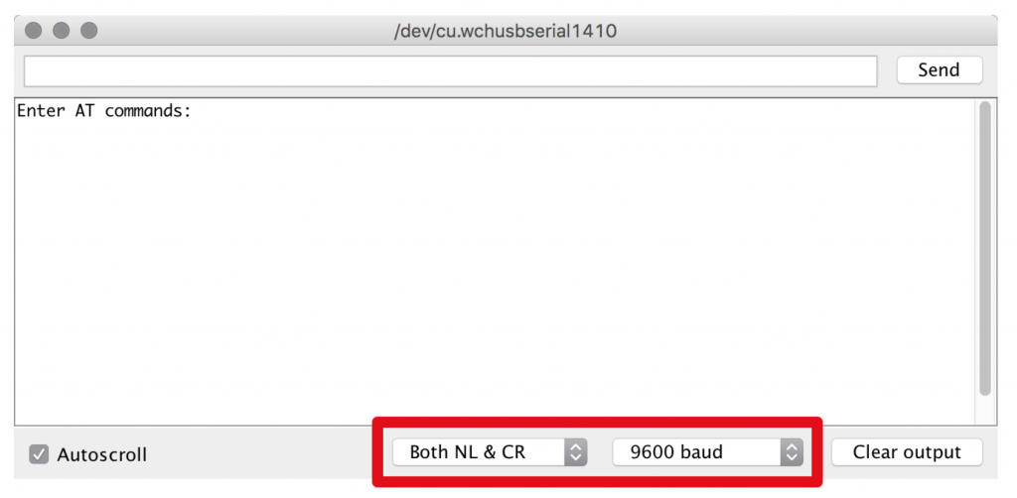
5. Type **AT** and click **Send**. You should see **OK**. Otherwise, recheck your wiring.  
   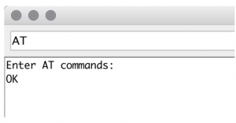
6. Type **AT+NAME=<your custom Bluetooth name>** and click **Send**.  
     
   For example, to change the default name to MY-HC-05, enter  
   **AT+NAME=MY-HC-05**.

**More AT Commands**

**AT+ORGL**  
Return the default settings

**AT+VERSION?**  
Show firmware version

**AT+PSWD=4567**  
Change default security code to 4567